**Ideal Seasonal Tendencies**

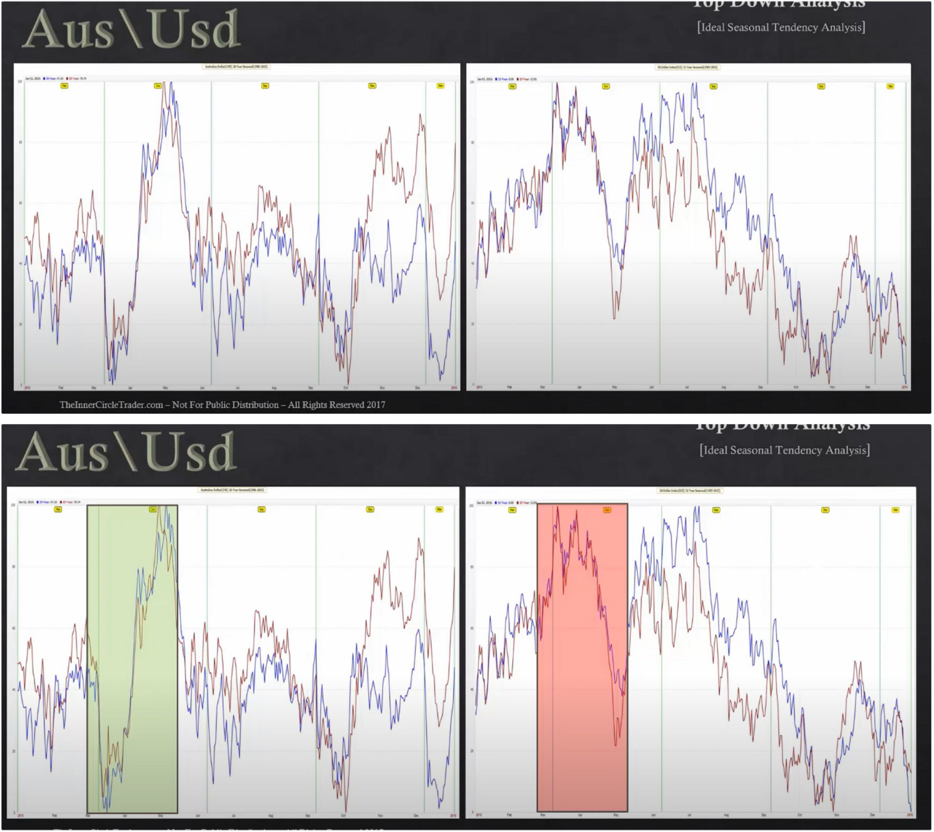

This is the ideal seasonal tendency for AUDUSD, AUD goes up dollar goes down Dollar seasonal tendencies

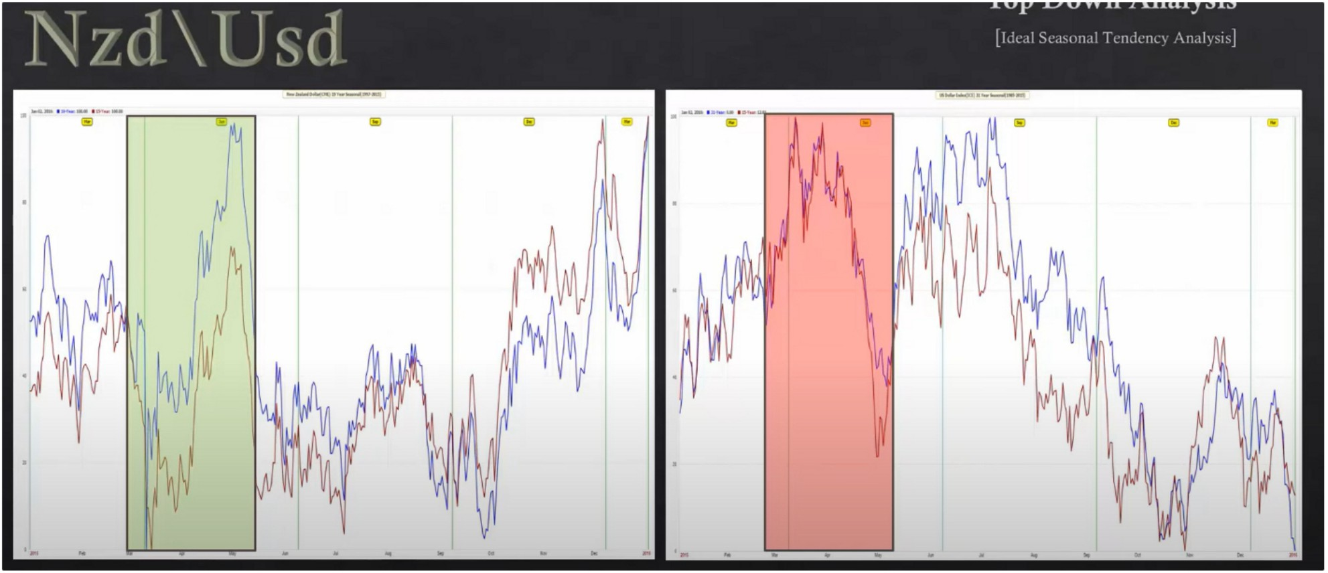

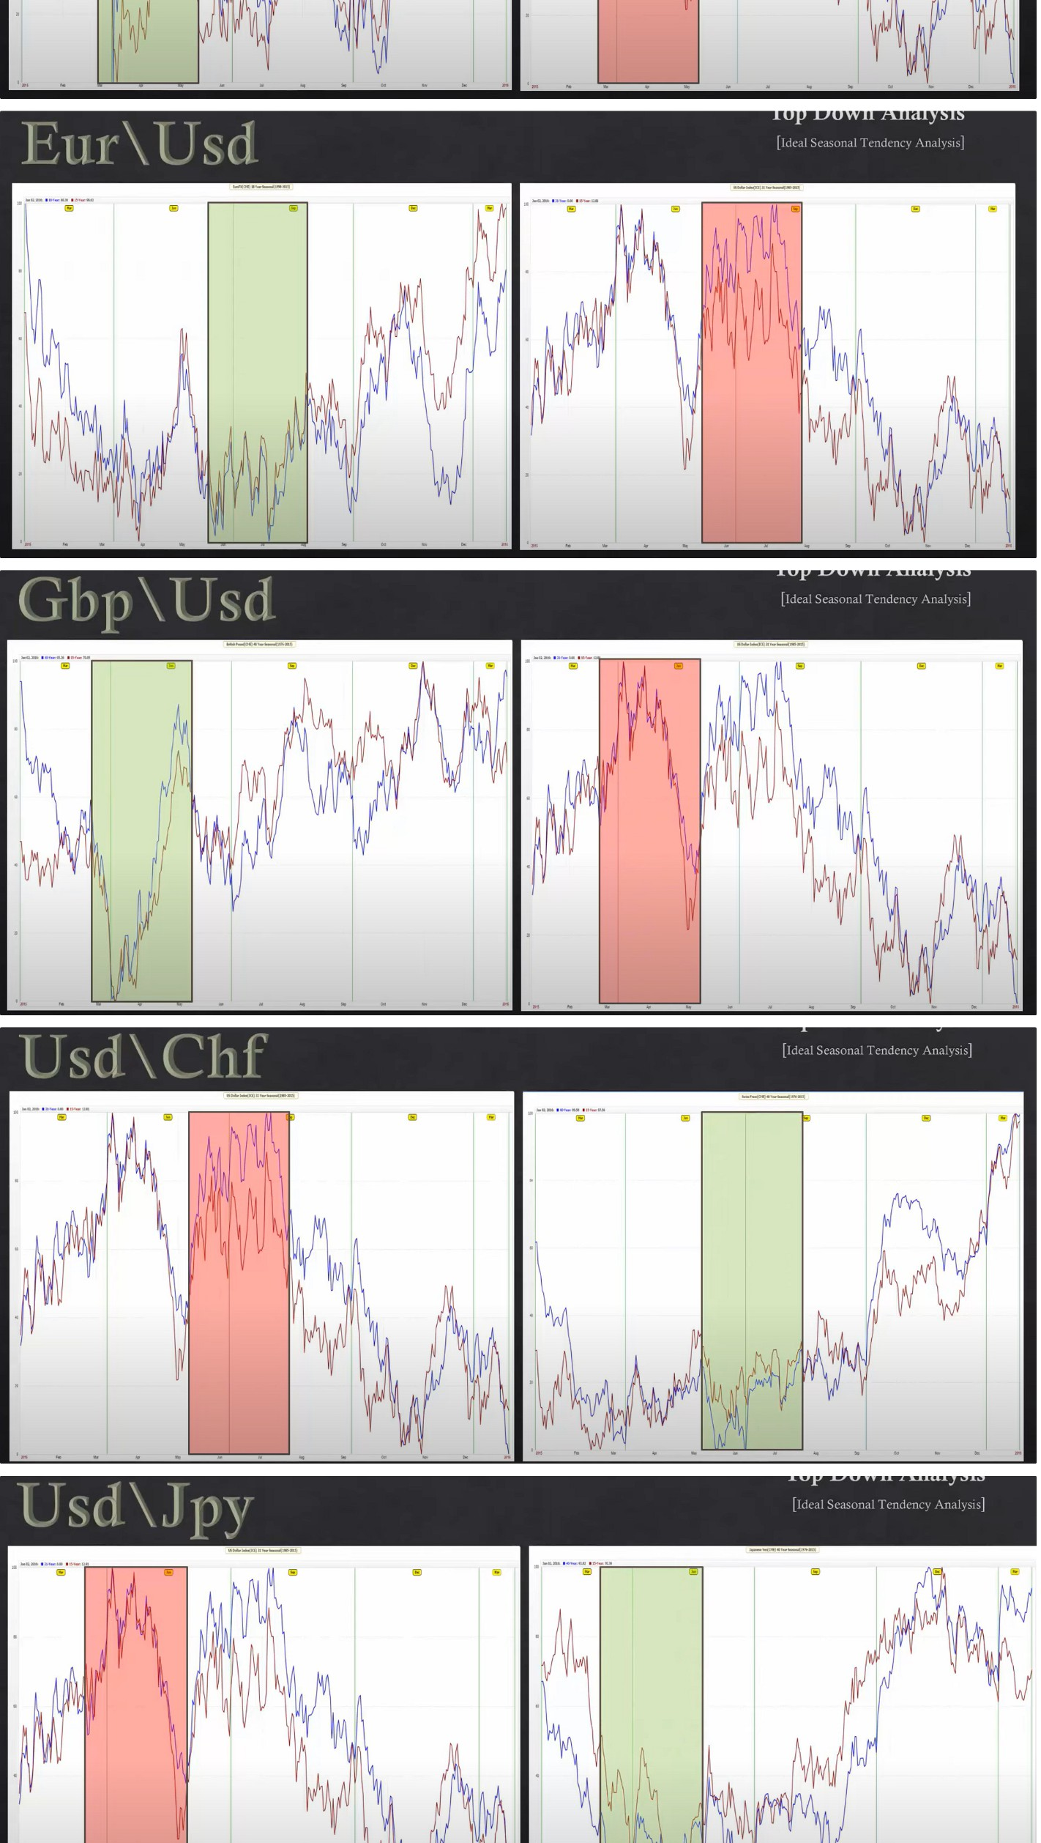

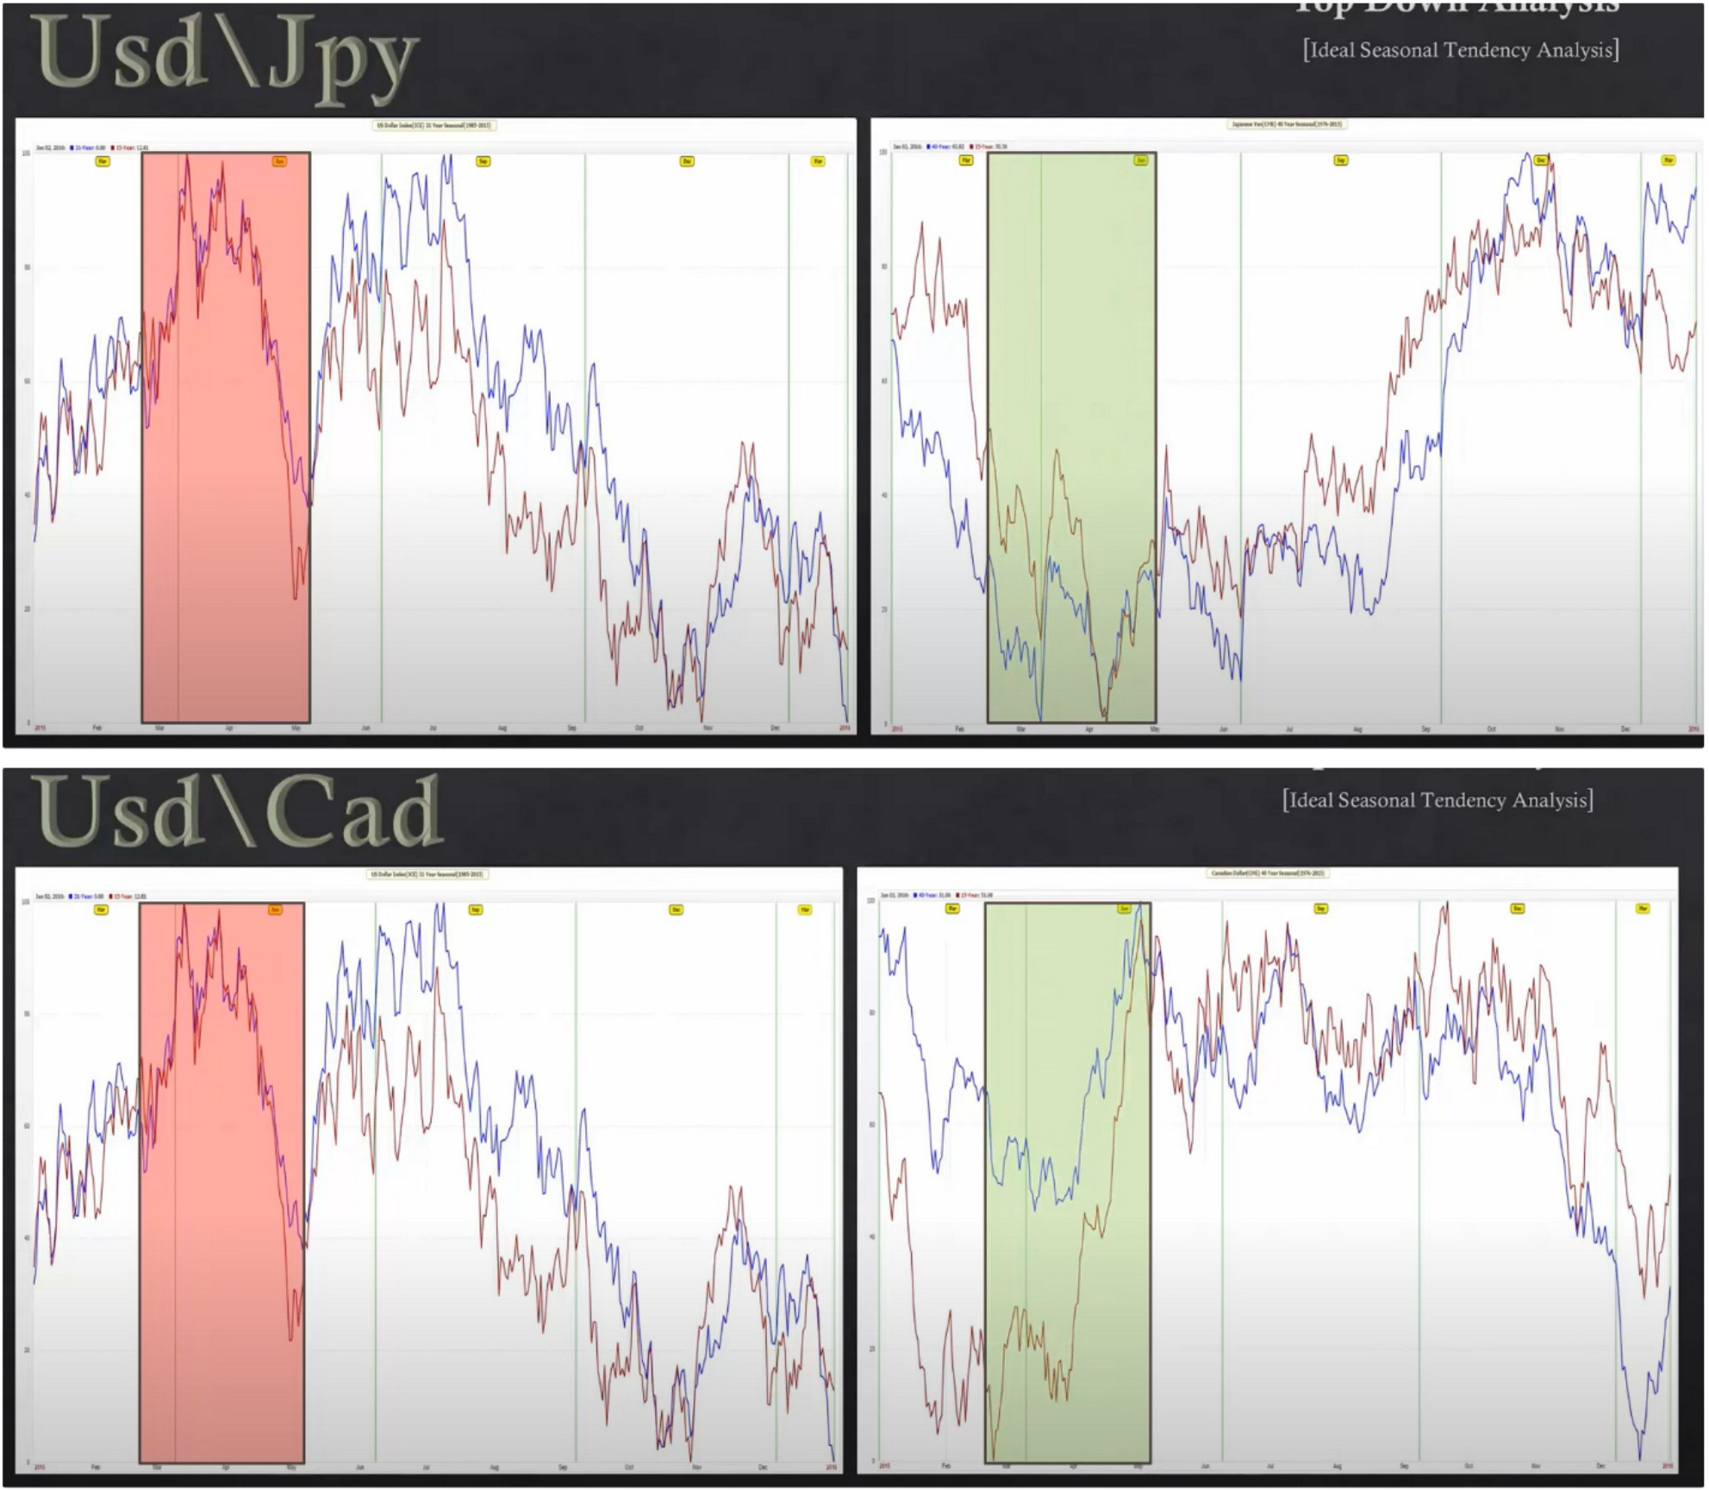

This is how you can see the highest probability seasonal tendencies

You want to have this at your desk, things to watch for this month and next month Always start your trading day with viewing macro analysis

Arjo I Twitter, lnstagram I Linktree

Linktree. Make your link do more.

I https://t.co/HhmmTN1fUI

JavaScript is not available.

'I# https://twitter.com/arjoio